Freshers’ Guide to Connecting to Wifi

There are several wifi networks available at Jesus College. If you’ve just arrived and want to get on the wifi as quickly as possible, please use TheCloud network, which is the same network that is available in many shops, bars and other business premises in the UK. The other networks you’ll see are Eduroam, JESU-WLAN and JC-Guest.

TheCloud
This is the Sky-branded network we use for guest access within the college – you may already have a login to this if you’ve used TheCloud previously elsewhere. If not, you can create a login when you connect to it – all you need is an email address. Just follow the instructions which will appear when you connect and you should be up and running within a minute or so. Connecting to TheCloud will get you up and running on wifi although you may find you can’t access some internal services from it which you may need later, such as the Webprint system.

JESU-WLAN
This is the main college wifi network, available at the Turl Street, Herbert Close, Stevens Close and Woodstock Road sites.
Connection to the network is by an initial wifi password which is shown in the letter you should have received with your college login details. Use the initial wifi password and you will be asked to agree to the Acceptable Use Policy and your device will be registered by our Bradford-Fortinac system. The registration process is generally straightforward but please be aware that the system is intended mainly for laptops and phones. Other devices such as printers or Sonos audio systems do not in general support the authentication methods needed to connect securely on a large wifi network. If you need guidance on what you can and can’t connect, please contact the IT department – it-support@jesus.ox.ac.uk
The registration process will require you to enter your Oxford SSO account login and password – typically this will be jesuxxxx where xxxx represents a four-digit number. You should already have set up your SSO password before arriving – the SSO accounts are provided by the university’s central IT Services department and they will send these details by letter or email.

Eduroam
Eduroam is the global wifi network which is offered by Universities and research establishments all around the world. Once you have your SSO account you can register for an Eduroam/remote access account using this page:
https://register.it.ox.ac.uk
It is worth bookmarking this page as it provides a number of other useful services as well.
You should set a different password for Eduroam/remote access to your SSO password, and you’ll probably need to wait a short while (usually 15 minutes or so) before you can log into Eduroam with your new account. Note that your Eduroam account password will expire after twelve months but you may not get a reminder about this – the password will nevertheless expire and you won’t be able to use Eduroam until you set a new one, using the same link above.

To connect to Eduroam, enter your SSO in the following format:
jesuxxxx@OX.AC.UK
The letters before the @ symbol should be in lower-case and the ones after it in upper-case.

Cabled connections
Most student rooms have network ports and you can also connect your device through these – however you will in most cases need to request a network connection from the IT Department, which may take a couple of days to provide. Please email it-support@jesus.ox.ac.uk for this, and include the name of the building you’re in and your flat and room number, and also the port number – this should be shown on a label on the port.

Printing
We run the Papercut Webprint service which will allow you to upload your file to a webserver and then print it to either the IT Lab or the Library printers. You need to be connected to the JESU-WLAN to use Webprint.
To use this facility, go to the On-line Services section of the Intranet :
https://intranet.jesus.ox.ac.uk/online-services
and click on “Everyone Print” which will bring up the Papercut login page. Log in with your Jesus College username and password and then select the Webprint menu on the left-hand side. Click the “Submit a Job” button and the system will then ask you to which printer queue you want the job submitted:

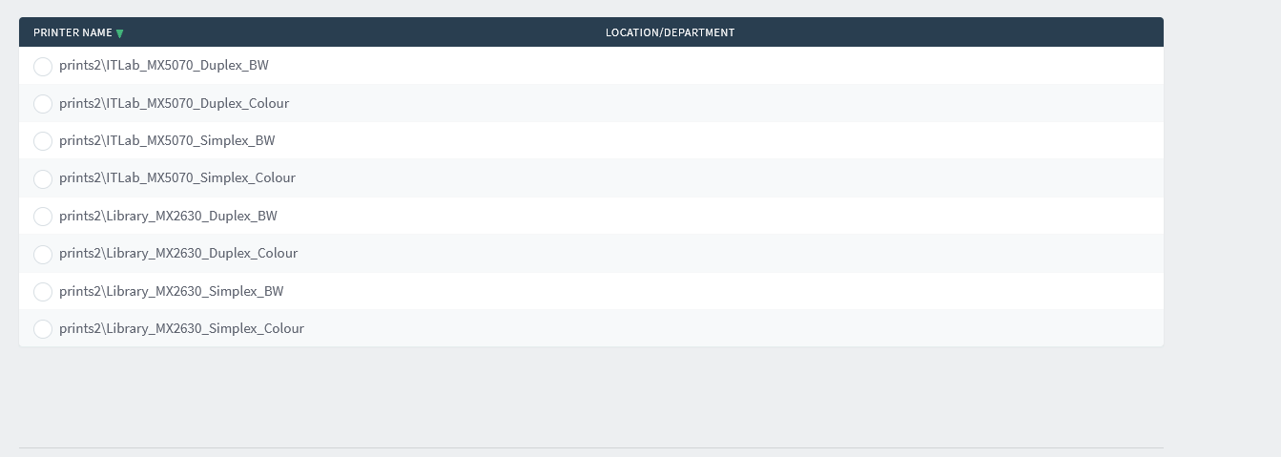

There are a number of different print queues to enable you to select different print formats – for example, “Duplex_BW” means your job will be printed in black and white, and on both sides of the paper. Simplex_Colour means that it will be printed single-sided in colour. Colour printing is expensive so you should only select the colour queues when your job warrants it.

Having selected the type of printing you want, you’ll then press the Print Options and Account Selection button. This will ask you to select the number of copies you want (the default is 1) and then the “Upload Documents” button will bring up a window which invites you to select the file you want to print, or you can drag and drop the file into the window. Follow the on-screen instructions and your job will be queued for printing.

Now go to the printer to which you’ve submitted your job. If your fob has already been associated with your college network account, you can simply sign in using the fob and you’ll then see the list of your print jobs waiting for the OK to print. You can either cancel or print them, and remember to sign out again before you leave the machine.

